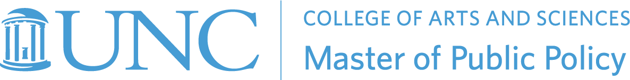

PLCY 992: Master’s Capstone in Public Policy
Memorandum of Understanding
Between
Student Name
and
Client Organization, Point of Contact Name

This Memorandum of Understanding (MOU) sets forth the terms of commitment between the PLCY 992 class participants and the [partner] for collaboration on the Semester-long Project in Spring 2023.

Purpose
The PLCY 992 Masters Capstone in Public Policy course will train an interdisciplinary group of graduate students to apply the mindsets, methods, and process associated with design thinking (i.e. human-centered design) to solve complex social, environmental and/or economic problems. Community partners who are tackling real world challenges ground the course in the form of an applied case study our students can collaborate on. Our goal is to build reciprocal value during the partnership - for the benefit of student learning and in the creation of impact with the community served.

Duration
This MOU is at-will and may be modified by mutual consent of authorized officials from [list partners]. This MOU shall become effective upon signature by the authorized officials from the [list partners] and will remain in effect until modified or terminated by any one of the partners by mutual consent. In the absence of mutual agreement by the authorized officials from [list partners] this MOU shall end in May 2024.

Terms

As a Semester-long project partner of PLCY 992, your organization will receive the following:

- Interaction with a master’s in public policy student with guidance from their advisor.
- A final paper including findings and recommendations to community partners at the conclusion of the semester long project.
- A final presentation with a slide deck.

In exchange, your organization agrees to:

- Appoint one person within the organization to serve as a primary contact person to the student;
- Commit approximately 2-3 hours per month during the spring 2023 semester to working with the student;
- Review written plans and section drafts, along with the final paper
- Attend final presentations;
- Complete feedback surveys so we can continue to improve the experiences for community partners; and
- With your approval, allow the Teaching Team to use Client’s name, logo, and student project in the policy program’s print and digital communications such as website, newsletters, press releases, and internal training documents. PLCY 992 is a required course in the Master of Public Policy degree program.
- Compete a brief survey at the end of the semester to give feedback to professors on student performance and overall experience

Compensation
There is no fee required to participate as a community partner. This partnership is offered in-kind as an experiential learning opportunity.

Partner Contact Information
Name of primary contact person:
E-mail:
Position:
Organization:
Address:
Telephone:

______________________
Partner signature

_________
Date

PLCY 992 Student Signature

Date

Brief Project Description (to be completed by student before submission to advisor):

