MPP Tuition and Fees 2022-2023 Academic Year

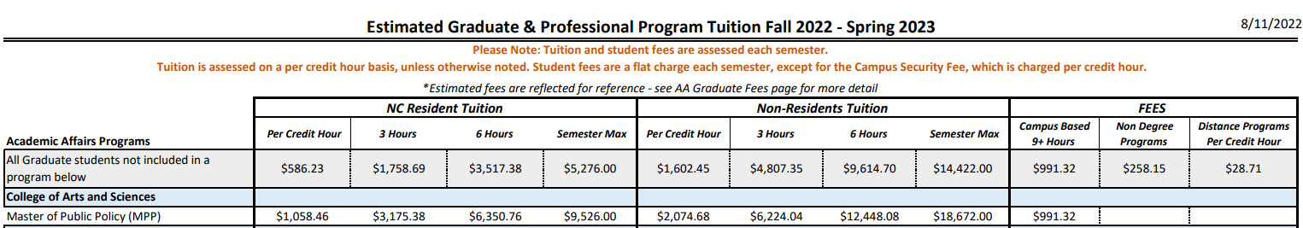

https://cashier.unc.edu/wp-content/uploads/sites/259/2022/07/graduate-and-professional-tuition-and-fees-fall-2022-spring-2023.pdf

Per credit hour:
$1,058.46 ($586.23 regular tuition + $472. 23 school-based tuition)

3 hours:
$3,175.38 ($1758.69 regular tuition + $1416.60 SBT)

6 hours:
$6,350.76 ($3,517.38 regular tuition + $2833.38 SBT)

9+ hours:
$9,526.00 ($5276 regular tuition + $4250 SBT)

