Kick-start your internship planning
Welcome to the MPP program! I’m Amanda Brumfield, and I’m a Research Instructor for the Department of Public Policy and a Professional Development & Career Coach in Honors Carolina. I’d love to meet with you to help with your internship search or answer any other career questions. I can help with:
- Resumes
- Cover letters
- Finding internships that fit your interests
- Interview prep
- And more!
To meet with me, book a meeting using Calendly: calendly.com/amandabrumfield
Here are my biggest tips to get you started:
- Update your resume to include your acceptance to the MPP program. There are several options for listing your degrees:
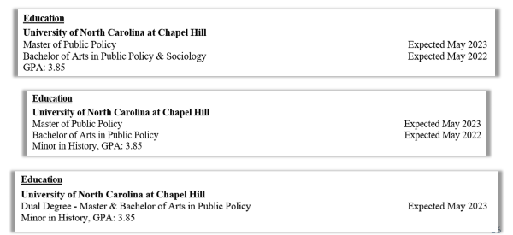
- Make sure your resume includes all of your relevant experience. This could include:
  - Relevant coursework, using full course names (3-4 courses max)
  - Policy Capstone, with strong specific bullets describing your work
  - Relevant skills, like Stata or R
  - Substantial course projects
- For cover letters, don’t just give a narrative of your resume. Instead, describe your most relevant skills for the posting you’re applying to, using keywords from the posting. In other words, make it crystal clear you have the skills they need.
- Apply to a diverse list of employers. The competition is fiercest at the biggest, most well-known employers in your field. Consider smaller employers or employers you’ve never heard of before (as long as you’re sure they’re legit!). Also, consider cold emails to places that look interesting but haven’t posted any openings – It can’t hurt.
Good luck! Feel free to set up a meeting or reach out with questions!

